**Gods and Goddesses**

**POWERPOINT NOTES**

2. There were 12 Olympian gods/goddesses who lived on Mount Olympus:

|  |  |
| --- | --- |
| **Gods** | **Goddesses** |
| Zeus | Demeter |
| Poseidon | Hestia (replaced by Dionysus) |
| Ares | Aphrodite |
| Hephaestus | Athena |
| Apollo | Artemis |
| Hermes | Hera |
| Hades lived in the underworld with Persephone | |

1. They were part of a big family.
2. **Zeus**

* Zeus was the son of Cronos and Rhea.
* Rhea kept him a secret from Cronos for fear that he would be eaten. Cronos was so terrified of his 12 children, because he had been warned by Mother Earth that one of his children would become a god and overthrow him, that he swallowed them all whole at birth. The baby, Zeus however, was entrusted to Mother Earth (Gaia) for safe-keeping and taken to the island of Crete for his protection. Cronos believed that he had nothing to fear, however, Mother Earth did not warn Cronos that Rhea would trick him by presenting a rock swaddled in cloth for him to eat believing it to be his new-born son, Zeus. On the island of Crete Zeus grew strong under the care of the nymphs.
* As he grew older Zeus became the god of weather and was able to throw thunderbolts down from heaven to earth. He earned himself nicknames such as the ‘cloud-gatherer’, ‘earth shaker’ and the ‘thunderer’.
* Typically, Zeus is depicted with a beard and a thunderbolt to show his power and control over the elements.
* Zeus is also linked with the eagle.

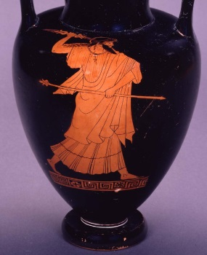

On this pottery red-figured neck amphora (used for storing wine and oil) made in Athens in the fifth century BC Zeus is represented striding to the right and hurling a thunderbolt. He also holds a sceptre as a sign of his kingly status. He is bearded and has long hair. He wears a long sleeved chiton (dress) and himation (cloak). British Museum Collection.

1. **Poseidon**

* Poseidon was the brother of Zeus.
* Poseidon was the god of the seas, earthquakes and horses (which is why the white foam of the sea is referred to as horses).
* It was decided that Poseidon should rule the sea when his brother Zeus put three precious stones into a helmet. The sapphire represented the Earth and sky, a turquoise represented the sea and a ruby represented the Underworld. Zeus drew out of the helmet first and pulled out the sapphire while Poseidon chose the turquoise and therefore gained control over the sea.
* Poseidon was held in high regard by the Greeks because seafaring was so important.
* Poseidon is generally depicted holding a trident.

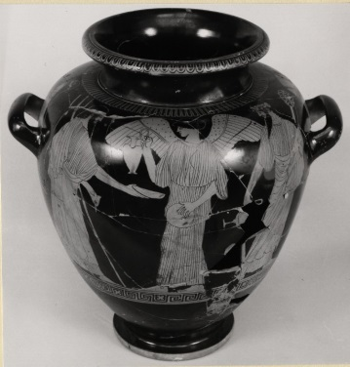

On this pottery red-figured stamnos (used for storing wine or for mixing wine and water) made in Athens in the fifth century BC Poseidon is represented with Nike and Dionysus. Poseidon is on the left, with a long sleeved chiton (dress) and mantle (cloak) he has a long beard and hair falling to his shoulders. He is holding a dolphin and a trident. Poseidon holds out a phiale (shallow dish) to be filled by Nike (winged goddess of victory) who moves towards him, holding up an oinochoe (jug). Nike also holds a phiale (shallow dish). Dionysos, bearded, wreathed with ivy, with long wavy hair, long sleeved chiton (dress) and mantle (cloak), holds a thyrsus (staff consisting of a fennel stalk topped with a pine cone wrapped in ivy) and drinking cup with high handles (kantharos). British Museum Collection.

1. **Hestia**

* The daughter of Cronus and Rhea and sister of Zeus.
* Hestia was the goddess of the hearth and tasked with protecting the house.
* Originally one of the Olympian goddesses she gave up her place to Dionysus.
* Hestia welcomed babies, brides and slaves into the household.
* With her strong connection to the household Hestia was housebound to ensure that the fire did not burn out.

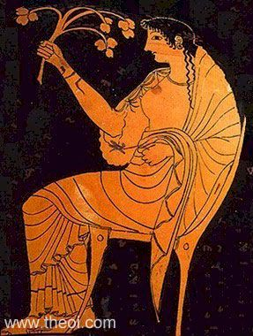

On this pottery red-figured kylix (cup for drinking wine) made in Athens in 525-475 BC Hestia is shown amongst the feasting gods of Olympus. She holds a branch. Museo Nazionale, Tarquinia.

1. **Demeter**

* Demeter was the daughter of Cronos and legend has it that Zeus forced Cronos to drink poison causing Demeter and her siblings to be coughed up by her father.
* Demeter, alongside her daughter Persephone, was the goddesses of plants and harvest and controlled the seasons on Earth.
* Demeter’s daughter Persephone was kidnapped by Hades who wanted to marry her. He took her to the Underworld. Persephone ate six pomegranate seeds in the Underworld which meant she could not leave permanently so for six months of the year Demeter mourned the loss of her daughter causing the weather to become cold and plants to die, creating the season winter. Demeter was reunited with her daughter for six months, and, during this time the crops grew and the weather was warm (creating the seasons spring and summer) as a result of her happiness.
* Demeter is represented by a sheaf of wheat or barley.

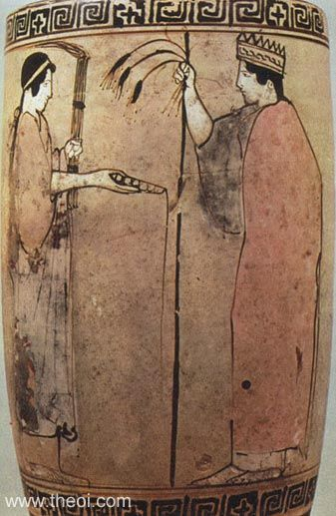

On this pottery white-ground lekythos (oil pot placed in the grave) made in Athens in the fifth century BC Demeter is shown on the right. She holds a sceptre and a sheaf of barley and wears a crown. Persephone stands in front of her with a torch and phiale (shallow dish). National Museum, Athens.

**Hades**

* Hades was the brother of Zeus.
* Hades was not considered an Olympian god and so ruled the Underworld alongside Persephone.
* Hades lends his name to the place where the souls of the dead are taken.
* The god Hades carried the souls of the dead to the Underworld which was not a nice place to be.

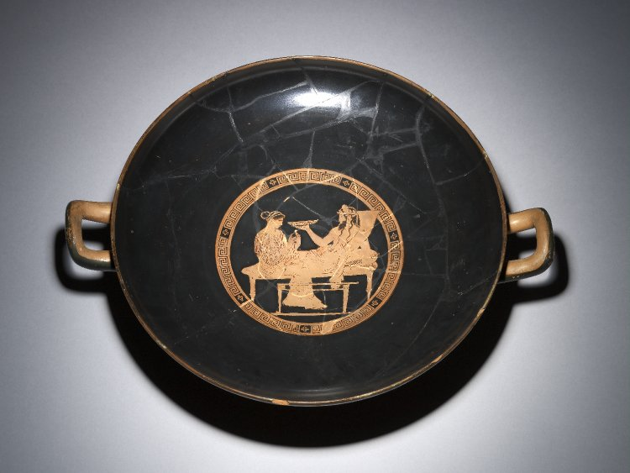

On this pottery red-figured kylix (cup for drinking wine) made in Athens in the fifth century Hades and Persephone are shown at a banquet. Hades reclines on a couch and Persephone sits by his feet. Hades wears his cloak around his waist and a sash tied around his head. A table is in front of the couch. Hades holds a giant drinking horn and a phiale (shallow dish). British Museum Collection.

1. **Hera**

* Hera, Zeus’ wife, was the Queen of the Olympian gods.
* Hera was the goddess of women, marriage and childbirth although her own marriage to Zeus was an unhappy one.
* Zeus had many relationships and Hera was jealous as she wanted Zeus all for herself.
* Hera was the mother of Ares and Hephaestus.

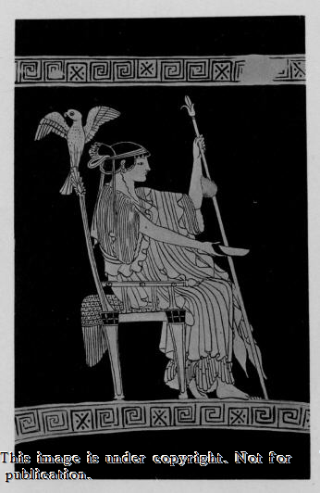

On this pottery red-figured lekythos (oil pot) made in Athens in the fifth century BC Hera is sitting on a throne decorated with a bird. She holds a phiale (shallow dish) in one hand and a sceptre in the other. Rhode Island Collection, New York.

1. **Ares**

* Ares was the son of Hera and Zeus.
* Ares was the god of war.
* Ares is typically depicted wearing armour and was considered a brave warrior.

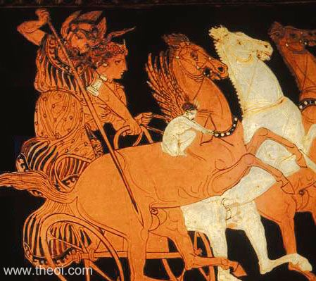

On this pottery red-figured amphora (storage pot for wine or oil) made in Athens in the late fifth century BC Ares and Aphrodite ride in a chariot. Ares holds a spear and wears a helmet. Eros (god of love) shoots an arrow. Louvre, Paris.

**Aphrodite**

* Some stories indicate that Aphrodite was the child of Zeus whereas other stories suggest that she was born from the sea foam.
* Aphrodite was the goddess of love and beauty.
* Aphrodite married her half-brother the blacksmith Hephaestus.

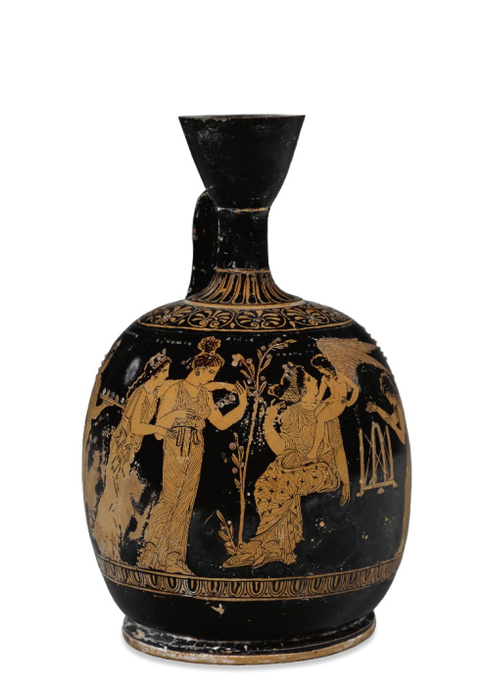

On this pottery red-figured squat lekythos (perfume container used by women) made in Athens in the late fifth century BC Aphrodite is represented with her friends in a garden. She wears a chiton (dress) and a cloak (embroidered with crosses), a hairband, earrings, a necklace and sandals. She sits on a little hill or rock beside a tree and Eros (the god of love) sits on her shoulder. British Museum Collection.

1. **Hephaestus**

* Hephaestus was the son of Hera.
* Hephaestus was the Greek god of fire and blacksmiths (or metalworking) as it is believed he owned the fire. As a result of this connection Hephaestus became the patron for craftsmen.
* Hephaestus was crippled from birth and because of this was thrown from Mount Olympus but he grew cunning with age and sought revenge on his mother and siblings who mocked him because his feet faced backwards.
* Unlike the other Olympian gods and goddesses Hephaestus was unattractive and was laughed at because he was not divinely beautiful.

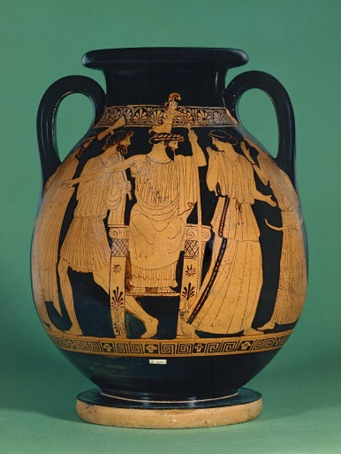

On this pottery red-figured pelike (storage pot for wine or oil) made in Athens in the fifth century BC the birth of Athena is represented. Zeus sits on a throne in the centre and out of his head pops Athena fully armed and running. Hephaestus stands beside the throne wearing a short chiton (dress) and carrying his double axe over his shoulder. He raises his hand because he is surprised. British Museum Collection.

**Athena**

* Athena burst from the head of Zeus after he swallowed her mother Metis. Zeus had a terrible headache and he later asked Hephaestus to cut his head open revealing his daughter Athena.
* Athena was the goddess of wisdom and war.
* Athena and Poseidon fought over the city of Athens. A vote was put to the people as to whose gift was more useful, a salt water spring or olive tree. Athena presented an olive tree which grew before her and won the hearts of the people and so the city of Athens became hers.
* The symbols of Athena represent her wisdom with the owl her bird of choice and the olive branch a continued source of food.

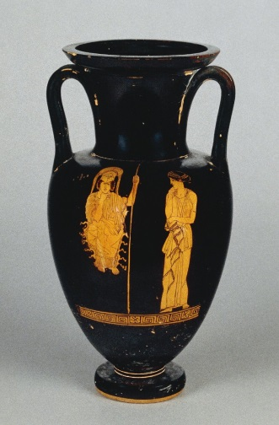

On this pottery red-figured amphora (storage pot for wine or oil) made in Athens in the fifth century Athena is seated on the left. She wears a chiton (dress) and cloak on top of which rests her snake-fringed aegis (special protective garment). She wears a helmet and holds a spear. Sometimes she has the gorgon’s head on her shield or aegis. British Museum Collection.

1. **Apollo**

* Apollo was the son of Zeus and twin brother of Artemis. Their mother was called Leto and they were said to have been born on the island of Delos.
* God of the Sun, Apollo controlled the movement of the Sun across the sky.
* Apollo was the god of healing and peace.
* Apollo was the patron of arts and music and his symbol was either the lyre or the laurel tree.
* The symbol of the laurel tree is represented because of his love for Daphne, a nymph. Daphne, however, did not feel the same way for Apollo and she appealed to Mother Earth to save her. Mother Earth transformed Daphne into a laurel tree and so Apollo wore a wreath of laurel leaves to remember her.
* Apollo was also believed to be a truth teller and pilgrims visited his sanctuary in Delphi for advice from the oracle.

**Artemis**

* Artemis was the daughter of Zeus and the twin sister of Apollo.
* Artemis was the goddess of the wild and hunting.
* Artemis played an important role in the lives of girls and women as goddess of childbirth and the rearing of children.
* Artemis is usually represented with a bow and arrow. She often carries a quiver (arrow case) and is associated with deer.

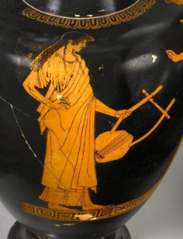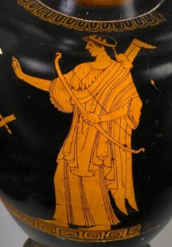

On this pottery red-figured oinochoe (jug for wine or water) made in Athens in the fifth century BC both Apollo and Artemis are represented: Apollo stands holding a lyre. He is a youthful beardless figure with long wavy hair, he wears a long sleeved chiton (dress) and himation (cloak).

Artemis holds a bow, and holds up her right hand as if talking to Apollo. She wears a long sleeved chiton (dress), himation (cloak) fastened on the left shoulder and a quiver. British Museum Collection.

1. **Hermes**

* Hermes was the son of Zeus and a nymph.
* Hermes is typically regarded as the messenger god as he was able to travel through to the Underworld.
* With this freedom to travel between the worlds Hermes guided the souls of the dead to the Underworld.
* Hermes had an excellent knowledge of roads which made him the ideal traveller’s patron.
* As well as the god of travel Hermes was also the god of business, weights and measures and sport.
* When he was a child Hermes was mischievous and stole cattle from Apollo. With his reputation for stealing Hermes was also associated with thievery and trade.
* Hermes is usually depicted wearing winged sandals and a winged helmet or sunhat (petasos) and holding a herald’s staff (caduceus). He often wears a short cloak.

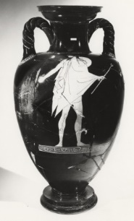 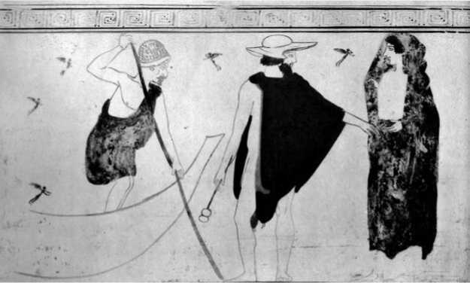

On this pottery red-figured amphora (storage pot for wine or oil) made in Athens in the fifth century Hermes stands holding his caduceus. He wears a short cloak, traveller’s sunhat (petasos) on his back and winged boots. British Museum Collection.

On this pottery white-ground lekythos (oil pot placed in the grave) made in Athens in the fifth century Hermes is in the centre. He wears his traveller’s hat and short cloak and holds his caduceus. He leads a woman towards Charon (the boatman who takes people who have died across the river to the underworld). The little ‘fairies’ in the background represent souls. National Archaeology Museum Athens.

1. **Dionysus**

* It is thought that Dionysus was born from the thigh of Zeus and he later became the cup-bearer to the gods.
* Dionysus was the god of wine.
* Dionysus is often represented drinking. The cup he uses most often is the kantharos, a cup with high handles.
* Dionysus is often depicted wearing a crown of ivy and grapevine leaves to emphasise his association with both wine and vegetation.
* He is often shown holding the thyrsus – a fennel stalk topped with a pinecone wrapped in ivy.
* Dionysus is associated with drama and merry-making and he toured the world teaching people how to make wine from grapes.

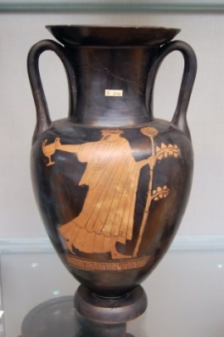 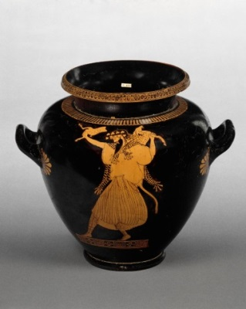

On this pottery red-figured amphora (storage pot for wine or oil) made in Athens in the fifth century BC Dionysus wearing a chiton (dress) and himation (cloak) and ivy wreath walks to the right. He holds a kantharos (drinking cup) in one hand and a thyrsus (fennel stalk with a pine cone on top often wrapped in ivy). British Museum Collection.

On this pottery red-figured stamnos (storage pot for wine or for mixing wine and water) made in Athens in the fifth century BC Dionysus is represented with a dead fawn which he has ripped in half. He wears a chiton (dress) and panther’s skin around his neck. He also wears high laced boots. Dionysos appears to be dancing. British Museum Collection.

1. Can you guess who the Greek gods are?

Key object photos: These two objects are in the Great North Museum



1. On this fragmentary marble relief Zeus is represented sitting on a throne beside an altar. There is an eagle underneath the throne. Zeus holds a phiale (shallow bowl) which would have been used in ritual to pour a libation.



1. This red-figure volute krater, made in Athens in the fifth century BC, would have been used for mixing wine and water at the drinking party. The Greeks always drank their wine diluted. Dionysus the god of wine is in the middle with his favourite drinking cup the kantharos. He also holds a thyrsus (fennel stalk with a pine cone on top which is often wrapped in ivy). The two women on either side of Dionysus are maenads. One holds a snake and the other has ripped a deer in half as part of the ritual.

**Now try the gods and goddesses colouring in poster or family tree**